EXP 1: no questions for practice (practical)
EXP 2:
Write a program to perform sparse matrix operations – addition and multiplications.
Exp 3: searching sorting
- Write a program to insert a new record into existing record
- Write a program to delete a record from existing record
- Write a program to arrange list of students in alphabetical order (Use Selection Sort )
EXP 4:singly linked list
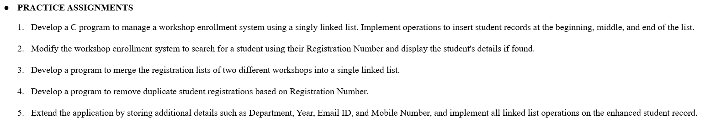
EXP 5: circular linked list:
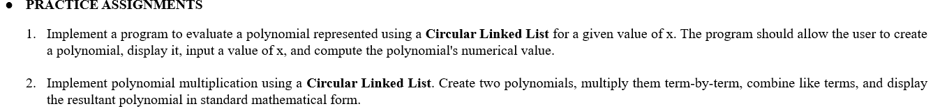
EXP 6: stack operations:
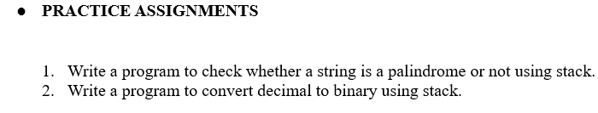
EXP 8 linear queue:
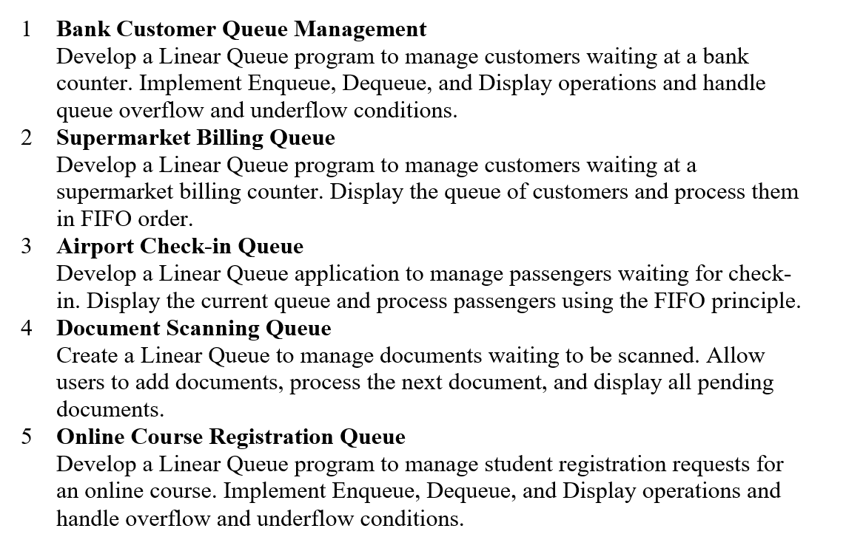
EXP 9: Circular queue:
